Wealth360 FSC Assessment
Technical Design Document

Version 1.0 | January, 2026
Author: Yannick Kayombo

Project | Financial Services Cloud Wealth Management Solution
Focus | External API Integration with Custom LWC Dashboard
Status | Enterprise Architecture Design

Table of Contents

1. Business Scenario

1.1 Overview
Wealth360 wants to give financial advisors a 360-degree view of a client's financial life. They already use Financial Services Cloud (FSC) with households and financial accounts.

1.2 Business Requirements
The solution must add visibility into external investment portfolio data from a 3rd-party API (such as Morningstar or a mock API) and build a custom Lightning Web Component dashboard to display portfolios alongside FSC out-of-the-box components. The platform needs to ensure scalability to support thousands of clients and portfolios.

2. Problem Statement

Financial advisors currently face significant challenges in providing comprehensive wealth management services. Client investment data is scattered across multiple external systems, requiring advisors to spend excessive time manually gathering portfolio information from various sources. This fragmented approach results in outdated portfolio performance data and prevents advisors from providing consistent, informed recommendations to their clients. The manual processes not only limit scalability as the client base grows but also introduce data accuracy issues and create compliance risks due to incomplete audit trails. Advisors spend a substantial portion of client meetings gathering and reconciling data instead of focusing on value-added advisory services, ultimately impacting client satisfaction and retention.

3. Solution Overview

3.1 Business Benefits
The Wealth360 solution significantly reduces the time advisors spend on manual data collection and preparation for client meetings, enabling them to focus on providing strategic investment advice. By automating the portfolio data retrieval process, the platform eliminates manual data entry errors and provides real-time insights during client interactions. Advisors gain access to comprehensive portfolio views within Salesforce, improving their productivity and enabling better-informed investment recommendations. The solution enhances the overall client experience through professional dashboards with visual analytics and instant access to transaction history, while maintaining complete audit trails for regulatory compliance. The scalable architecture supports business growth and positions the organization competitively in the wealth management market.

4. Technical Architecture

4.1 Conceptual End-to-End Architecture
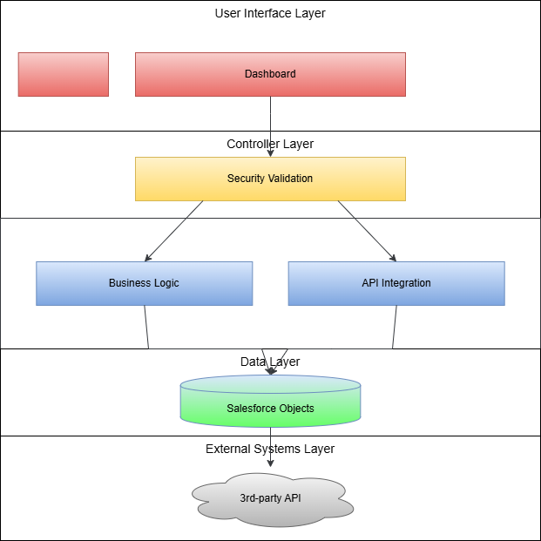

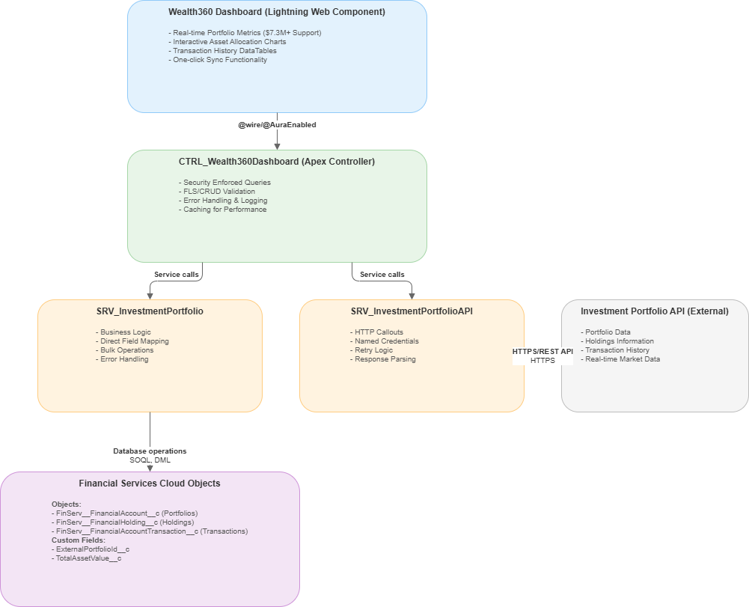

4.2 Architecture Principles
Separation of Concerns
- Clear boundaries between presentation, business logic, and integration layers
- Each tier has specific responsibilities and dependencies
Security by Design
- Named Credential for secure API authentication
Scalability & Performance
- Bulk processing patterns for large datasets
- Asynchronous operations where appropriate
- Efficient SOQL queries with proper indexing
Maintainability
- Service-oriented architecture
- Reusable components
- Clear error handling patterns

5. Data Model

5.1 Entity Relationship Diagram
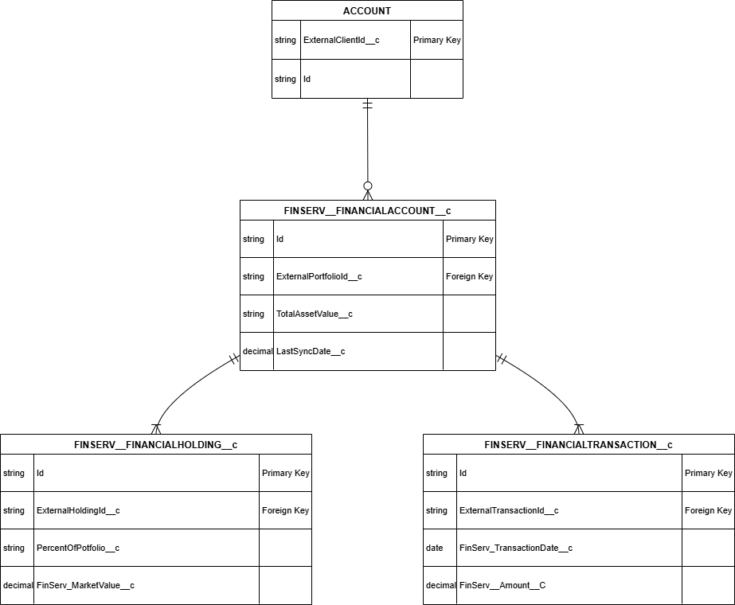

- Account (Person Account - Client)
- FinServ__FinancialAccount__c (Investment Portfolio)
- FinServ__FinancialHolding__c (Asset Position)
- FinServ__FinancialAccountTransaction__c (Transaction Record)

5.2 Custom Fields
Standard/Custom | Type of Field | Related Object | Name | Description | Help Text | Action | Notes
Custom field | Text(50) | Account | ExternalClientId__c | Unique identifier from external system | Used for API integration | New | External ID, Unique
Custom field | DateTime | Account | LastSyncDate__c | Timestamp of last portfolio sync | Tracks last successful sync | New | Read-only field
Custom field | Text(50) | FinServ__FinancialAccount__c | ExternalPortfolioId__c | Unique portfolio ID from external API | Links to external system | New | External ID, Unique, Required
Custom field | Currency | FinServ__FinancialAccount__c | TotalAssetValue__c | Calculated total portfolio value | Sum of all holdings | New | Formula field, auto-calculated
Custom field | DateTime | FinServ__FinancialAccount__c | LastSyncDate__c | Last successful data sync timestamp | Tracks portfolio data freshness | New | Auto-populated on sync
Custom field | Text(50) | FinServ__FinancialHolding__c | ExternalHoldingId__c | Unique holding ID from external API | Links to external security | New | External ID, Unique, Required
Custom field | Percent | FinServ__FinancialHolding__c | PercentOfPortfolio__c | Calculated percentage of portfolio | Auto-calculated from market value | New | Formula field
Custom field | Text(50) | FinServ__FinancialAccountTransaction__c | ExternalTransactionId__c | Unique transaction ID from external API | Links to external transaction | New | External ID, Unique, Required
Custom field | Long Text Area | FinServ__FinancialAccountTransaction__c | Description__c | Detailed transaction description | Stores transaction details | New | Max 32,000 characters

5.3 Data Model Design Decisions
External ID Strategy
- All custom external ID fields use Text(50) format
- Enable upsert operations for efficient data synchronization
- Prevent duplicate records from external systems
Master-Detail Relationships
- Holdings and Transactions use Master-Detail to Financial Account
- Ensures data integrity and automatic cascade delete
- Roll-up summary fields for portfolio calculations

6. Integration Design

6.1 Integration Flow Diagram
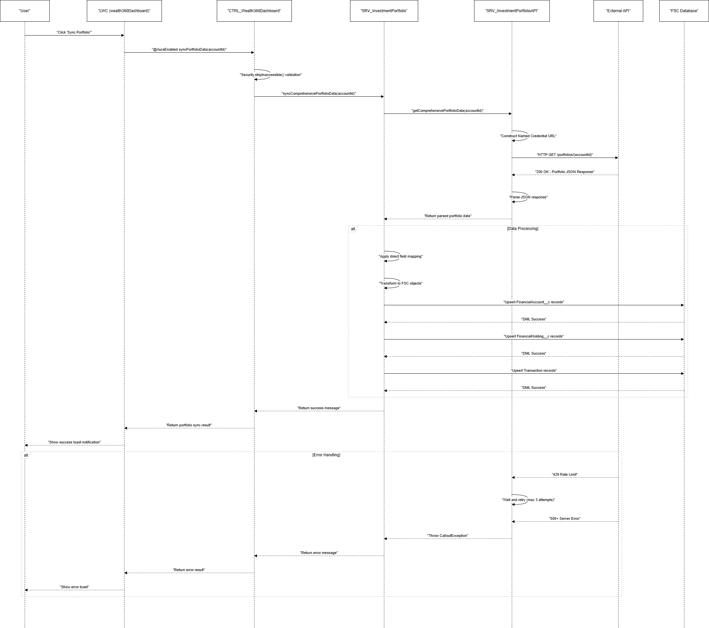
1. User initiates portfolio sync from LWC dashboard
2. Lightning Web Component calls Apex controller
3. Controller validates user permissions and security
4. Service layer makes HTTP callout to external API
5. Named Credential handles OAuth 2.0 authentication
6. External API returns portfolio, holdings, and transaction data
7. Response parser transforms JSON to Apex objects
8. Business service applies field mapping logic
9. Bulk DML operations upsert data to Salesforce
10. UI refreshes with success/error notification

6.2 API Integration Details
Endpoint Configuration
Base URL: Configured in Named Credential
Endpoint: /api/v1/portfolios/{clientId}/comprehensive
Method: GET
Authentication: OAuth 2.0 via Named Credential
Request Parameters
Parameter | Type | Required | Description
clientId | String | Yes | External client identifier
includeHoldings | Boolean | No | Include holdings data (default: true)
includeTransactions | Boolean | No | Include transaction history (default: true)
transactionDays | Integer | No | Days of transaction history (default: 90)

Response Structure
{
"success": true,
"timestamp": "2026-01-16T10:30:00Z",
"portfolios": [
{
"portfolioId": "PORT-001",
"name": "Retirement Portfolio",
"totalValue": 750000.00,
"currency": "ZAR",
"status": "Active",
"holdings": [...],
"transactions": [...]
}
]
}

6.3 Error Handling Strategy
Retry Logic
- Maximum 3 retry attempts
- Exponential backoff: 1s, 2s, 4s
- Only retry on 5xx server errors and timeouts
Partial Success Handling
- Process valid records even if some fail
- Log all errors for troubleshooting
- Return detailed error information to user

7. Security & Compliance

7.1 Authentication & Authorization
Named Credential Security
- OAuth 2.0 token-based authentication
- Automatic token refresh handling
Salesforce Security Model
- Profile and Permission Set based access control
- Field-Level Security (FLS) enforcement
- Object-Level Security (CRUD) validation
- Sharing rules for advisor-client relationships

8. Solution Components

8.1 Lightning Web Components
Related Object | Name | Description | Action | Notes
Account | wealth360Dashboard | Main portfolio dashboard component displaying comprehensive portfolio information with real-time sync capability | New | Displays portfolio metrics, asset allocation charts, and transaction history with one-click sync

8.2 Business Logic - Apex Classes
Related Object | Name | Description | Action | Notes
Account | CTRL_Wealth360Dashboard | Main controller for wealth360Dashboard LWC | New | Implements @AuraEnabled methods with security enforcement
Account | CTRL_Wealth360Dashboard_Test | Test class for CTRL_Wealth360Dashboard | New | Achieves 100% code coverage with positive and negative test scenarios
FinServ__FinancialAccount__c | SRV_InvestmentPortfolio | Core business logic service for portfolio data processing | New | Handles field mapping, data transformation, and bulk DML operations
FinServ__FinancialAccount__c | SRV_InvestmentPortfolio_Test | Test class for SRV_InvestmentPortfolio | New | Tests all service methods with bulk data scenarios
FinServ__FinancialAccount__c | SRV_InvestmentPortfolioAPI | External API integration service | New | Manages HTTP callouts, OAuth authentication, and retry logic
FinServ__FinancialAccount__c | SRV_InvestmentPortfolioAPI_Test | Test class for SRV_InvestmentPortfolioAPI | New | Uses mock HTTP responses for comprehensive API testing
FinServ__FinancialAccount__c | DTO_Wealth360Dashboard | Data transfer objects for clean layer communication | New | Wrapper classes for API responses and UI data structures
FinServ__FinancialAccount__c | DTO_Wealth360Dashboard_Test | Test class for DTO_Wealth360Dashboard | New | Validates wrapper class serialization and deserialization
Account | MOCK_InvestmentPortfolioAPI | Mock HTTP callout class for testing | New | Implements HttpCalloutMock for unit test isolation
Account | TEST_DataFactory | Centralized test data factory | New | Creates Account, Financial Account, Holdings, and Transaction test data
Account | TEST_DataFactory_Test | Test class for TEST_DataFactory | New | Validates test data creation methods

8.3 Custom Metadata & Configuration
Named Credentials
Name | Authentication Type | Scope | Purpose | Notes
InvestmentPortfolioAPI | OAuth 2.0 | Full API access | Secure authentication for external API calls | SSL/TLS certificate validation enabled, 120 second timeout

Permission Sets
Name | Description | Key Permissions | Target Users
Wealth360_Advisor_Access | Financial advisor access to Wealth360 functionality | Read/Write on FSC objects, Execute Apex classes, Access LWC components | Financial advisors, relationship managers
Wealth360_Manager_Access | Administrative access to Wealth360 | All Advisor permissions plus Modify All, View All on FSC objects | System administrators, wealth management managers

8.4 Component Summary
Total Components
Component Type | Count | Details
Lightning Web Components | 1 | wealth360Dashboard (5 files total)
Apex Classes | 11 | 6 production classes + 5 test classes
Custom Fields | 9 | Across Account, Financial Account, Holdings, and Transactions
Named Credentials | 1 | InvestmentPortfolioAPI
Permission Sets | 2 | Advisor and Manager access levels

Integration Components
- Named Credential for secure OAuth 2.0 authentication
- External ID fields for idempotent upsert operations
- Bulk DML patterns for scalable data processing
- Comprehensive error handling and logging throughout

Appendix

A. Glossary
Term | Definition
FSC | Financial Services Cloud - Salesforce industry solution
LWC | Lightning Web Component - Modern UI framework
Named Credential | Salesforce feature for secure API authentication
External ID | Field used to maintain links with external systems
Person Account | Account representing an individual client
Portfolio | Collection of financial investments
Holding | Individual asset within a portfolio
DML | Data Manipulation Language - Salesforce database operations
FLS | Field-Level Security - Permission to access specific fields
CRUD | Create, Read, Update, Delete - Object-level permissions

End of Document

